







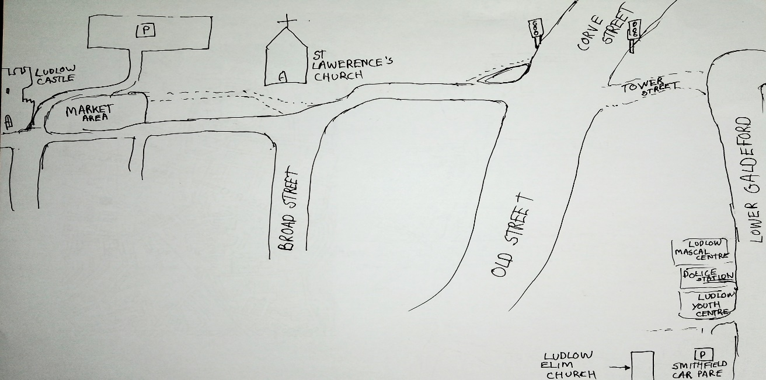

LUDLOW YOUTH CENTRE
POLICE STATION
LUDLOW MASCAL CENTRE

LUDLOW ELIM
CHURCH
ST
LAURENCE'S
CHURCH
LUDLOW
CASTLE
MARKET
AREA
BROAD STREET
WHAT TO DO……..
LOOK IN THE WINDOWS OF THE SHOPS ALONG THIS ORANGE LINE TO GET THE LETTERS ON THE EGGS TO SOLVE THE MESSAGE BELOW….. THEN COME TO US AT LUDLOW ELIM FOR A PRIZE AND A BOUNCE
LOWER GALDEFORD
OLD STREET
CORVE STREET

TOWER STREET

